**HACC DOE Project Requirements**

Client:  
 DOE  
 [Hilary Apana-McKee](mailto:Hilary_Apana-McKee/OCISS/HIDOE@notes.k12.hi.us)

Reference Documentation:   
 [OCISS Repository](https://sites.google.com/hawaiidoe.k12.hi.us/techdigitalrepository/home) on GoogleDocs

[HACC Summary Document](https://docs.google.com/document/d/1VFs7mdeefRhlS6F_ENJ9bOJ88H5px3KIe5PoI3h7FlQ/edit)

Goal - Develop a robust online educator hub that becomes the “go to” resource space for educators.

Idea - To create an online portal where educators can access the following types of services:

* Teacher Match - educators are “matched” based on their profile (content area, pedagogy, etc.) in order to support one another and grow their practice. Able to connect with like-minded elementary and secondary teachers who have common interests and goals.
  + Teacher Match SPFX Webpart
* Community Partners - video segments highlighting community partner sites showcasing what they offer and how educators can connect to them (i.e. Cheap Eats - Guy Hagi).
  + [O365 Stream](https://web.microsoftstream.com/)
* Coaching Opportunities - request system for virtual coaching and/or face-to-face coaching/mentoring opportunities.
  + Teacher Match SPFX Webpart
* Resource Hub - searchable database for lesson plans, curricular resources, subject matter experts, etc. (i.e. Amazon Inspire, Pinterest) which could include rating and commenting system.
  + [OCISS Repository on O365](https://ksbetest.sharepoint.com/sites/dev/ociss/default.aspx)
* Innovation Spaces - map/list of physical spaces where teachers can go to network, study, and do creative thinking.
  + O365 Group - collaboration with professionals cross organization
  + O365 Teams - collaboration with staff
  + O365 Yammer - collaboration with students
* Action Research - space to publish action research projects, request to be a part of an action research project, or submit ideas for action research projects.
  + O365 Groups (Professional Learning Communities)? e.g. [HACC Group](https://outlook.office.com/owa/?path=/group/haccgroup@ksbetest.onmicrosoft.com/people)
* Virtual Lesson Observation - mechanism to record lessons and get feedback (i.e. Edthena) or mechanism to conduct synchronous lesson observations. User could also have the ability to publish their virtual lesson to the Resource Hub.
  + Lesson Creation Functionality not covered by anything in O365 but final products might reside in OCISS Repository or O365 Stream for lookup/matchmaking capability via Teacher Match SPFX Webpart or Delve.

**Teacher Match SPFX WebPart Requirements**

Functional Requirements (Navigation, Storage, Data Manipulation):

1. Lookup (Search Capability) - Phase I (in scope)
   1. People Lookup (People, Groups, etc)
   2. Resource Lookup (Files, Lesson Plans, Workshops, Documentation, Field Trips, etc)
   3. Other Lookup (Other Objects that don’t fit People or Resource)
2. Advanced Search, History and/or Favorites Storage - Phase II (not in scope)
   1. As suspected, someone is already doing this [here](https://techcommunity.microsoft.com/t5/Office-365-Groups/quot-My-Groups-quot-list-for-SharePoint-Homepage-Web-Part/m-p/44824#M2015).

Non-Functional Requirements (User Interface, Design, Look and Feel):

1. Browser UI
   1. Simple 3 section layout suitable for both Browser and Mobile UI
   2. 3 Sections Like Google Navigation
2. Mobile UI
   1. Limited Real Estate
   2. 3 Sections Like Google Navigation
      1. STATUS BAR: Top 20% for status display
      2. MAIN AREA: Mid 70% for search and search results
      3. ACTION BAR: Bottom 10% for mode/view change adv search, favorites etc.

|  |
| --- |
| STATUS BAR  (Logged In User Profile) |
| Search Bar: Button for single click auto search, freeform Text Search field |
| MAIN AREA  Search Results 1: People that match my Projects or Schools & Education |
| Search Results 2: Files that match my Projects or Schools & Education |
| Search Results 3: Other things that match my Projects or Schools & Education |
| ACTION BAR |

Office 365 User Profile Example:  
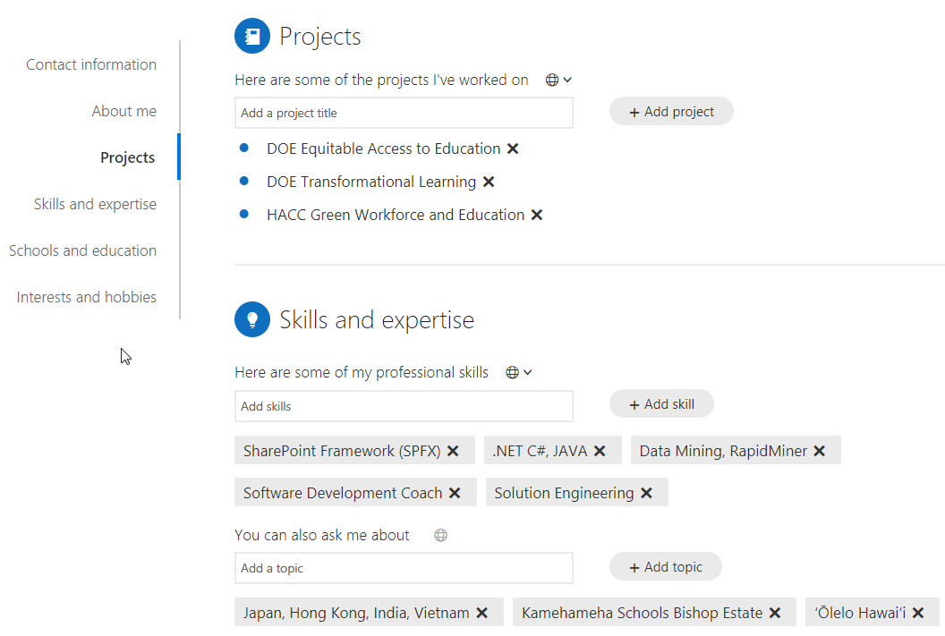

Office 365 Delve Lookup Example: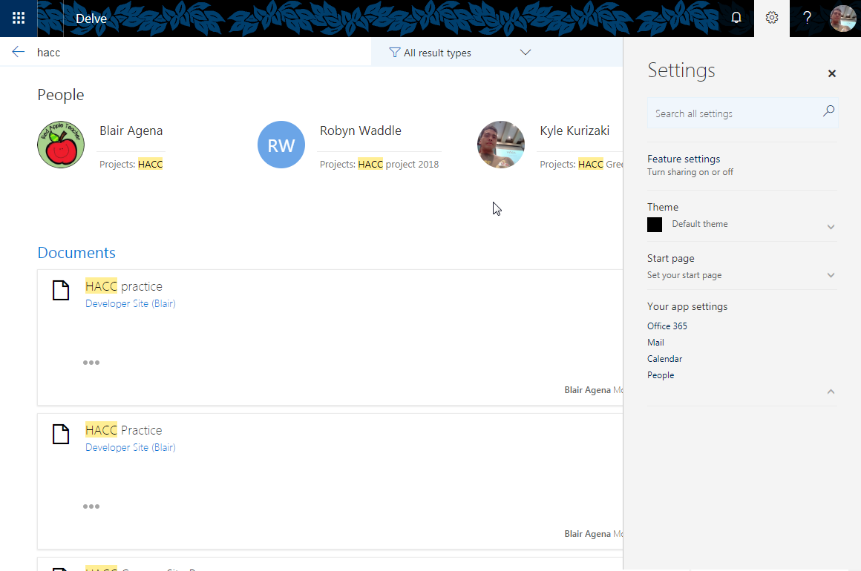

Prototype Template

